**JDBC – OUTPUT:**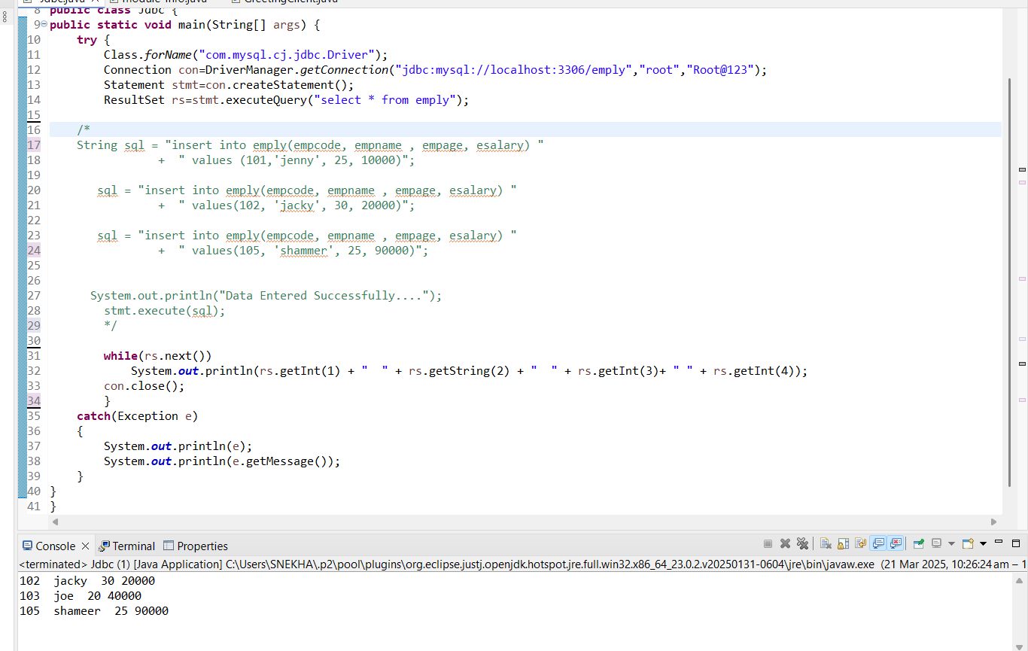

**MYSQL OUTPUT:**

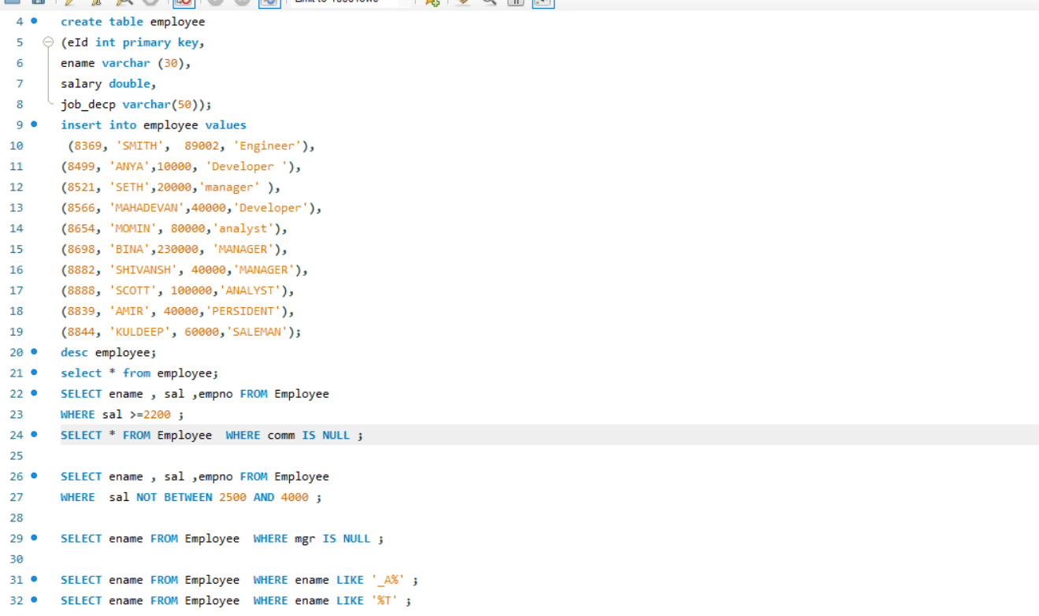

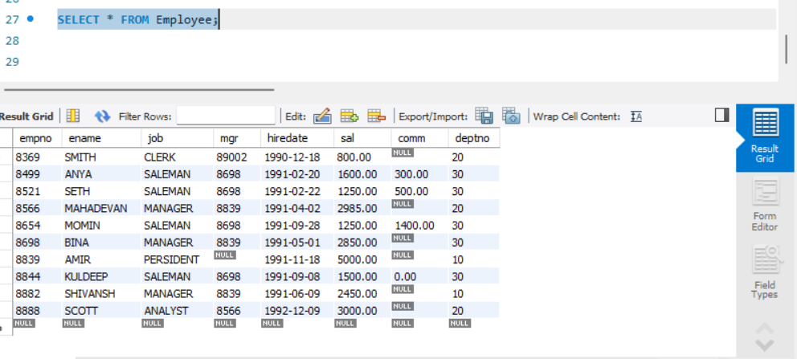

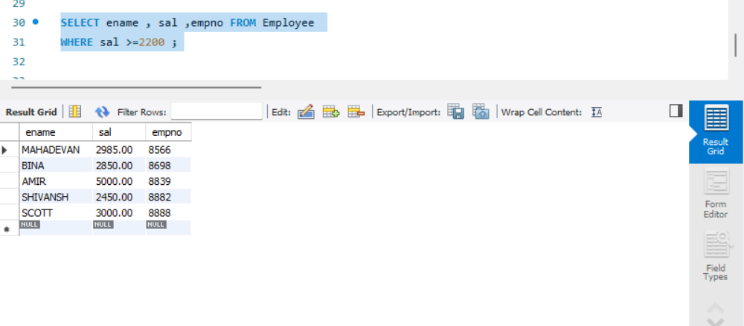

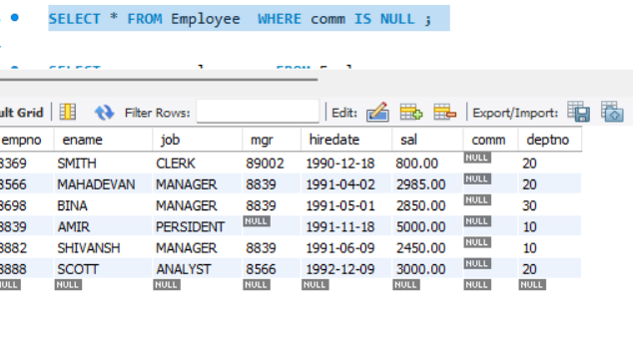

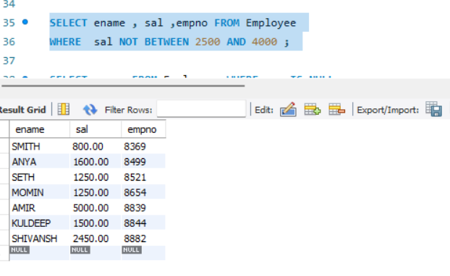

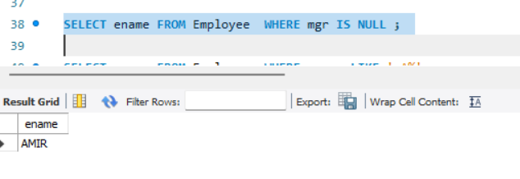

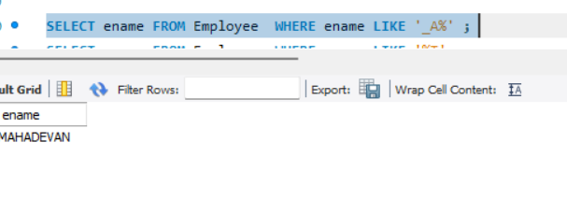

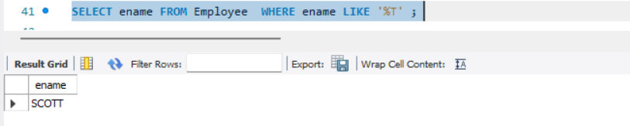

**MONGODB – OUTPUT:**

product> use Product

switched to db Product

Product> db.collection.find()

[

{

_id: 1,

product_name: 'Intelligent Fresh Chips',

product_price: 655,

product_material: 'Concrete',

product_color: 'mint green'

},

{

_id: 2,

product_name: 'Practical Fresh Sausages',

product_price: 911,

product_material: 'Cotton',

product_color: 'indigo'

},

{

_id: 3,

product_name: 'Refined Steel Car',

product_price: 690,

product_material: 'Rubber',

product_color: 'gold'

},

{

_id: 4,

product_name: 'Gorgeous Plastic Pants',

product_price: 492,

product_material: 'Soft',

product_color: 'plum'

},

{

_id: 5,

product_name: 'Sleek Cotton Chair',

product_price: 33,

product_material: 'Fresh',

product_color: 'black'

},

{

_id: 6,

product_name: 'Awesome Wooden Towels',

product_price: 474,

product_material: 'Plastic',

product_color: 'orange'

},

{

_id: 7,

product_name: 'Practical Soft Shoes',

product_price: 500,

product_material: 'Rubber',

product_color: 'pink'

},

{

_id: 8,

product_name: 'Incredible Steel Hat',

product_price: 78,

product_material: 'Rubber',

product_color: 'violet'

},

{

_id: 9,

product_name: 'Awesome Wooden Ball',

product_price: 28,

product_material: 'Soft',

product_color: 'azure'

},

{

_id: 10,

product_name: 'Generic Wooden Pizza',

product_price: 84,

product_material: 'Frozen',

product_color: 'indigo'

},

{

_id: 11,

product_name: 'Unbranded Wooden Cheese',

product_price: 26,

product_material: 'Soft',

product_color: 'black'

},

{

_id: 12,

product_name: 'Unbranded Plastic Salad',

product_price: 89,

product_material: 'Wooden',

product_color: 'pink'

},

{

_id: 13,

product_name: 'Gorgeous Cotton Keyboard',

product_price: 37,

product_material: 'Concrete',

product_color: 'sky blue'

},

{

_id: 14,

product_name: 'Incredible Steel Shirt',

product_price: 54,

product_material: 'Metal',

product_color: 'white'

},

{

_id: 15,

product_name: 'Ergonomic Cotton Hat',

product_price: 43,

product_material: 'Rubber',

product_color: 'mint green'

},

{

_id: 18,

product_name: 'Licensed Plastic Bacon',

product_price: 88,

product_material: 'Steel',

product_color: 'yellow'

},

{

_id: 19,

product_name: 'Intelligent Cotton Chips',

product_price: 46,

product_material: 'Soft',

product_color: 'azure'

},

{

_id: 21,

product_name: 'Unbranded Granite Chicken',

product_price: 90,

product_material: 'Metal',

product_color: 'gold'

},

{

_id: 22,

product_name: 'Ergonomic Soft Hat',

product_price: 99,

product_material: 'Rubber',

product_color: 'black'

},

{

_id: 23,

product_name: 'Intelligent Steel Pizza',

product_price: 95,

product_material: 'Cotton',

product_color: 'azure'

}

]

Type "it" for more

Product> db.collection.find({ product_price: { $gte: 400, $lte: 800 }})

[

{

_id: 1,

product_name: 'Intelligent Fresh Chips',

product_price: 655,

product_material: 'Concrete',

product_color: 'mint green'

},

{

_id: 3,

product_name: 'Refined Steel Car',

product_price: 690,

product_material: 'Rubber',

product_color: 'gold'

},

{

_id: 4,

product_name: 'Gorgeous Plastic Pants',

product_price: 492,

product_material: 'Soft',

product_color: 'plum'

},

{

_id: 6,

product_name: 'Awesome Wooden Towels',

product_price: 474,

product_material: 'Plastic',

product_color: 'orange'

},

{

_id: 7,

product_name: 'Practical Soft Shoes',

product_price: 500,

product_material: 'Rubber',

product_color: 'pink'

}

]

Product> db.collection.find({ product_price: { "$not": { $gte: 400, $lte: 80

0 } }})

[

{

_id: 2,

product_name: 'Practical Fresh Sausages',

product_price: 911,

product_material: 'Cotton',

product_color: 'indigo'

},

{

_id: 5,

product_name: 'Sleek Cotton Chair',

product_price: 33,

product_material: 'Fresh',

product_color: 'black'

},

{

_id: 8,

product_name: 'Incredible Steel Hat',

product_price: 78,

product_material: 'Rubber',

product_color: 'violet'

},

{

_id: 9,

product_name: 'Awesome Wooden Ball',

product_price: 28,

product_material: 'Soft',

product_color: 'azure'

},

{

_id: 10,

product_name: 'Generic Wooden Pizza',

product_price: 84,

product_material: 'Frozen',

product_color: 'indigo'

},

{

_id: 11,

product_name: 'Unbranded Wooden Cheese',

product_price: 26,

product_material: 'Soft',

product_color: 'black'

},

{

_id: 12,

product_name: 'Unbranded Plastic Salad',

product_price: 89,

product_material: 'Wooden',

product_color: 'pink'

},

{

_id: 13,

product_name: 'Gorgeous Cotton Keyboard',

product_price: 37,

product_material: 'Concrete',

product_color: 'sky blue'

},

{

_id: 14,

product_name: 'Incredible Steel Shirt',

product_price: 54,

product_material: 'Metal',

product_color: 'white'

},

{

_id: 15,

product_name: 'Ergonomic Cotton Hat',

product_price: 43,

product_material: 'Rubber',

product_color: 'mint green'

},

{

_id: 18,

product_name: 'Licensed Plastic Bacon',

product_price: 88,

product_material: 'Steel',

product_color: 'yellow'

},

{

_id: 19,

product_name: 'Intelligent Cotton Chips',

product_price: 46,

product_material: 'Soft',

product_color: 'azure'

},

{

_id: 21,

product_name: 'Unbranded Granite Chicken',

product_price: 90,

product_material: 'Metal',

product_color: 'gold'

},

{

_id: 22,

product_name: 'Ergonomic Soft Hat',

product_price: 99,

product_material: 'Rubber',

product_color: 'black'

},

{

_id: 23,

product_name: 'Intelligent Steel Pizza',

product_price: 95,

product_material: 'Cotton',

product_color: 'azure'

},

{

_id: 25,

product_name: 'Licensed Steel Car',

product_price: 20,

product_material: 'Cotton',

product_color: 'indigo'

}

]

Product> db.collection.find({"product_price": {"$gte": 500}}).limit(4)

[

{

_id: 1,

product_name: 'Intelligent Fresh Chips',

product_price: 655,

product_material: 'Concrete',

product_color: 'mint green'

},

{

_id: 2,

product_name: 'Practical Fresh Sausages',

product_price: 911,

product_material: 'Cotton',

product_color: 'indigo'

},

{

_id: 3,

product_name: 'Refined Steel Car',

product_price: 690,

product_material: 'Rubber',

product_color: 'gold'

},

{

_id: 7,

product_name: 'Practical Soft Shoes',

product_price: 500,

product_material: 'Rubber',

product_color: 'pink'

}

]

Product> db.collection.find({},{ product_name: 1, product_material: 1})

[

{

_id: 1,

product_name: 'Intelligent Fresh Chips',

product_material: 'Concrete'

},

{

_id: 2,

product_name: 'Practical Fresh Sausages',

product_material: 'Cotton'

},

{

_id: 3,

product_name: 'Refined Steel Car',

product_material: 'Rubber'

},

{

_id: 4,

product_name: 'Gorgeous Plastic Pants',

product_material: 'Soft'

},

{

_id: 5,

product_name: 'Sleek Cotton Chair',

product_material: 'Fresh'

},

{

_id: 6,

product_name: 'Awesome Wooden Towels',

product_material: 'Plastic'

},

{

_id: 7,

product_name: 'Practical Soft Shoes',

product_material: 'Rubber'

},

{

_id: 8,

product_name: 'Incredible Steel Hat',

product_material: 'Rubber'

},

{

_id: 9,

product_name: 'Awesome Wooden Ball',

product_material: 'Soft'

},

{

_id: 10,

product_name: 'Generic Wooden Pizza',

product_material: 'Frozen'

},

{

_id: 11,

product_name: 'Unbranded Wooden Cheese',

product_material: 'Soft'

},

{

_id: 12,

product_name: 'Unbranded Plastic Salad',

product_material: 'Wooden'

},

{

_id: 13,

product_name: 'Gorgeous Cotton Keyboard',

product_material: 'Concrete'

},

{

_id: 14,

product_name: 'Incredible Steel Shirt',

product_material: 'Metal'

},

{

_id: 15,

product_name: 'Ergonomic Cotton Hat',

product_material: 'Rubber'

},

{

_id: 18,

product_name: 'Licensed Plastic Bacon',

product_material: 'Steel'

},

{

_id: 19,

product_name: 'Intelligent Cotton Chips',

product_material: 'Soft'

},

{

_id: 21,

product_name: 'Unbranded Granite Chicken',

product_material: 'Metal'

},

{

_id: 22,

product_name: 'Ergonomic Soft Hat',

product_material: 'Rubber'

},

{

_id: 23,

product_name: 'Intelligent Steel Pizza',

product_material: 'Cotton'

}

]

Type "it" for more

Product> db.collection.find({_id: 10})

[

{

_id: 10,

product_name: 'Generic Wooden Pizza',

product_price: 84,

product_material: 'Frozen',

product_color: 'indigo'

}

]

Product> db.collection.find({},{ product_name: 1, product_material: 1})

[

{

_id: 1,

product_name: 'Intelligent Fresh Chips',

product_material: 'Concrete'

},

{

_id: 2,

product_name: 'Practical Fresh Sausages',

product_material: 'Cotton'

},

{

_id: 3,

product_name: 'Refined Steel Car',

product_material: 'Rubber'

},

{

_id: 4,

product_name: 'Gorgeous Plastic Pants',

product_material: 'Soft'

},

{

_id: 5,

product_name: 'Sleek Cotton Chair',

product_material: 'Fresh'

},

{

_id: 6,

product_name: 'Awesome Wooden Towels',

product_material: 'Plastic'

},

{

_id: 7,

product_name: 'Practical Soft Shoes',

product_material: 'Rubber'

},

{

_id: 8,

product_name: 'Incredible Steel Hat',

product_material: 'Rubber'

},

{

_id: 9,

product_name: 'Awesome Wooden Ball',

product_material: 'Soft'

},

{

_id: 10,

product_name: 'Generic Wooden Pizza',

product_material: 'Frozen'

},

{

_id: 11,

product_name: 'Unbranded Wooden Cheese',

product_material: 'Soft'

},

{

_id: 12,

product_name: 'Unbranded Plastic Salad',

product_material: 'Wooden'

},

{

_id: 13,

product_name: 'Gorgeous Cotton Keyboard',

product_material: 'Concrete'

},

{

_id: 14,

product_name: 'Incredible Steel Shirt',

product_material: 'Metal'

},

{

_id: 15,

product_name: 'Ergonomic Cotton Hat',

product_material: 'Rubber'

},

{

_id: 18,

product_name: 'Licensed Plastic Bacon',

product_material: 'Steel'

},

{

_id: 19,

product_name: 'Intelligent Cotton Chips',

product_material: 'Soft'

},

{

_id: 21,

product_name: 'Unbranded Granite Chicken',

product_material: 'Metal'

},

{

_id: 22,

product_name: 'Ergonomic Soft Hat',

product_material: 'Rubber'

},

{

_id: 23,

product_name: 'Intelligent Steel Pizza',

product_material: 'Cotton'

}

]

Type "it" for more

Product> db.collection.find({product_material: { "$eq": "Soft" }})

[

{

_id: 4,

product_name: 'Gorgeous Plastic Pants',

product_price: 492,

product_material: 'Soft',

product_color: 'plum'

},

{

_id: 9,

product_name: 'Awesome Wooden Ball',

product_price: 28,

product_material: 'Soft',

product_color: 'azure'

},

{

_id: 11,

product_name: 'Unbranded Wooden Cheese',

product_price: 26,

product_material: 'Soft',

product_color: 'black'

},

{

_id: 19,

product_name: 'Intelligent Cotton Chips',

product_price: 46,

product_material: 'Soft',

product_color: 'azure'

}

]

Product> db.collection.find({ "$or": [{product_color: "indigo" },{product_prproduct_price: 492.00 }]})

[

{

_id: 2,

product_name: 'Practical Fresh Sausages',

product_price: 911,

product_material: 'Cotton',

product_color: 'indigo'

},

{

_id: 4,

product_name: 'Gorgeous Plastic Pants',

product_price: 492,

product_material: 'Soft',

product_color: 'plum'

},

{

_id: 10,

product_name: 'Generic Wooden Pizza',

product_price: 84,

product_material: 'Frozen',

product_color: 'indigo'

},

{

_id: 25,

product_name: 'Licensed Steel Car',

product_price: 20,

product_material: 'Cotton',

product_color: 'indigo'

}

]

